Instructions for North Carolina
Municipal Employee Pyrotechnic Assistant Operators Permit Application
The following material is being provided as instructions and a check list for the Municipal Employee Pyrotechnic Assistant Operator Application
PURSUANT TO NORTH CAROLINA GENERAL STATUTE 95-25.5 (b) - ALL ASSISTANT APPLICANTS MUST BE A MINIMUM OF 18 YEARS OF AGE.
1. Include 2 inch by 2 inch photo taken within six months of the date of application. This photo will be attached to the application by OSFM personnel and may be visible on internet records strictly related to your permit.
2. Check type of permit desired, new or renewal. Provide permit number for renewals. The applicant must fill out one application for each individual permit applied for or renewed. An application for a Proximate and Pyrotechnic Operator will require two separate applications.
3. Fill out number one on the application completely including all home address and telephone information. This information must match the information on the driver’s license or government issued ID if Applicable. The e-mail address appearing in this box should be your primary e-mail address, but does not necessarily have to be your personal e-mail address.
4. Fill out section two completely, including all pertinent information regarding the business for which you are employed. Owners and operators may check the “same as above” box if the information is the same as section one.
5. Fill out information for questions 3 through 12. Failure to complete any one of the questions or provide details regarding “yes” answers will result in denial of the application.
6. For application section 13, submit the following:
Attachment A (Driver’s License or other Government Issued photo ID if Applicable)
Attachment B (2 inch x 2 inch photo taken within last six months)
Attachment C (1 Reference May use “Reference Letter form” from web site - Not required if applicant is licensed in another state)
Attachment D (Professional Licenses held in other states, photocopy all listed licenses)
7. Section 14 (Pyrotechnics Assistant Operators) Submit the following:

Federal regulations regarding responsible parties require all non-municipal employees to be properly documented through the ATF. As a municipal employee performing as an operator of a pyrotechnic event supplied by the municipality, the applicant is exempt from the ATF documentation process. OSFM requires the verification of the following information from all municipal applicants:
1) An experience affidavit from the municipality manager identifying the following information:
- The municipality desires the applicant to perform the pyrotechnic events.
- The applicant is employed in good standing by the municipality providing the event.

2) For volunteer firefighters that may not be considered municipal employees, The chief of the fire department must provide a letter, on fire department letter head indicating that the firefighter is covered against injury under the fire department’s workers compensation insurance, which must include an additional endorsement for pyrotechnic activities.
PERMITS RECEIVED BY PROVIDING THIS APPLICATION WILL BE LIMITED TO THE MUNICIPALITY FOR WHICH THE APPLICANT RECEIVES AN EXPERIENCE AFFIDAVIT. TO ADD ADDITIONAL MUNICIPALITIES TO THE LIMITED PERMIT, THE APPLICANT MUST SUBMITT ALL DOCUMENTS DETAILED IN #1 FROM THE MANAGER OF THE ADDITIONAL MUNICIPALITY. IF #2 IS APPLICABLE TO THE APPLICANT, THEN THE FIRE CHIEF SHALL SUBMIT A LETTER INDICATING COVERAGE FOR THE ADDITIONAL MUNICIPALITY. THE LIMITED PERMIT WILL BE EFFECTIVE FOR A THREE YEAR PERIOD. THE PERMIT IS VOID UPON TERMINATION OF EMPLOYMENT.

Copy of municipal experience affidavit (Attachment E May Use “Municipal Experience Affidavit - Assistant” from web site)

Copy of insurance certificate for the initial event to be performed as required by G.S.14-410 and 14-413. (Attachment F)

Copy of Fire Chief letter identifying applicant by name and additional endorsement for pyrotechnics activity. (Attachment G May Use “Example Chief Letter” from website)

8. Section 16 Attach $30.00 check or money order payable to “The North Carolina Department of Insurance.”
9. Provide signature and print name legibly in the space provided, provide contact information and date. Please submit this application to:
Office of State Fire Marshal
Pyrotechnic Permitting
1202 Mail Service Center
Raleigh NC, 27699-1202

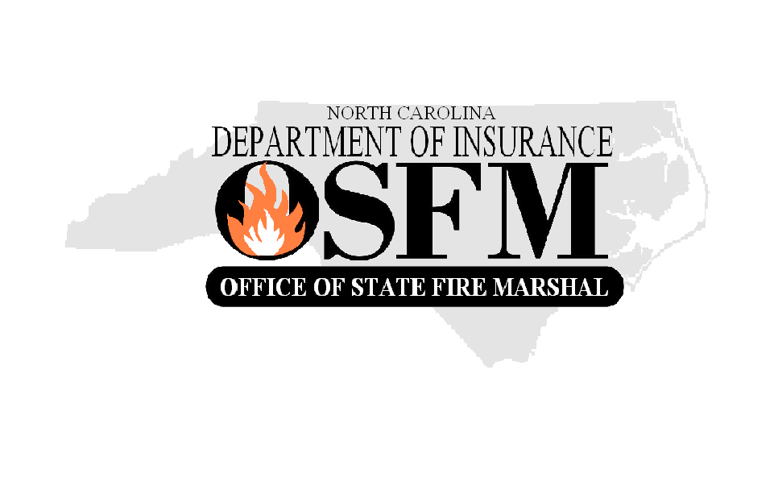
FOR OFFICIAL USE ONLY

Attach Photo Here

North Carolina
Department of Insurance
Office of State Fire Marshal
1202 Mail Service Center
Raleigh, NC 27603-3400

Permit Type: 􀂅 Pyro 􀂅 Prox
Permit No.: __________________
Permit Expiration Date ____________________________

Application for Pyrotechnic Assistant Operator Permit
For Municipal Employee Outdoor Professional Pyrotechnics

Any person that conducts pyrotechnic or flame effect displays in N.C. must be permitted by the OSFM pursuant to N.C. General Statute (14-410) Please provide the following information
(TYPE OR PRINT IN BLACK INK):

Position of Applicant:

New Applicant: 􀂅 Municipal Employee 􀂅 Volunteer Firefighter
Renewal: 􀂅 Municipal Employee 􀂅 Volunteer Firefighter Permit # ______________

- Name / Address of Applicant
FOR OFFICIAL USE ONLY

PGI Qualification
Certificate Attached 􀂅 Yes 􀂅 No

APA Qualification
Certificate Attached 􀂅 Yes 􀂅 No

Other OSFM Approved Class
___________________ _____________
INSTRUCTOR DATE

Name: ______________________________________
Address: ____________________________________
City: _________________________ State: _________
Zip Code: _________ County: ___________________
Phone: ( ) ______________________________
Fax: ________________________________________
E-Mail Address: _____________________________

- Name / Address Municipality of Employment 􀂅 SAME AS ABOVE

Name: ______________________________________________________________________
Address: ____________________________________________________________________
City: ________________________________ State: __________________________
Zip Code: _________________ County: ___________________________________
Phone: ( ) _________________________________ Fax: __________________________________
E-Mail Address: ________________________________________________

Application for Assistant Pyrotechnic Operator Permit
For Outdoor Professional or Proximate Audience

Each of the following questions must be answered by checking the “Yes” or
“No” box. Give full details on a separate sheet for each “Yes” answer.
Yes No
3. Has a court ever declared you incompetent by reasons of mental or physical
defect or disease? 􀂅 􀂅

4. Have you ever been committed to a mental institution? 􀂅 􀂅

5. Do you have an addiction to or dependency on alcohol or drugs? 􀂅 􀂅

6. Are you a fugitive from justice? 􀂅 􀂅

7. Are you an undocumented immigrant to the United States? 􀂅 􀂅

8. Are you under indictment in any court for a felony, or any crime for which
the judge could imprison you for more than one year? 􀂅 􀂅

9. Have you ever been discharged from the armed forces under dishonorable
conditions? 􀂅 􀂅

10. Having been a citizen of the United States, have you ever renounced your
citizenship? 􀂅 􀂅

11. Have you ever willfully violated any provisions of the Pyrotechnic
Operator Permitting Law (NCGS14-410)? 􀂅 􀂅

12. Have you made a material misstatement or knowingly withheld information
in connection with any original or renewal license application? 􀂅 􀂅

13. All Applicants Must Submit the Following:
􀂅 A copy of your driver's license or other government issued identification that includes
the date of birth and photograph. Submit as Attachment A.

􀂅 A photograph (2 inch x 2 inch) taken within the preceding six months. The photograph must
be clear, front view, full face, head and shoulders only, without sunglasses, hats,
scarves or any object that obscures the identity of the applicant. Submit as Attachment
B.

􀂅 Personal references from at least one individual who can attest to your character.
Submit list as Attachment C. (Not required if applicant is ATF Licensed or licensed in another state)

􀂅 A list of pyrotechnic licenses issued to the applicant by other states. Submit as
Attachment D. A photocopy of all listed licenses shall be included with this application; consideration will not be given to listed licenses without an accompanying photocopy.

PYROTECHNIC PERMIT APPLICANTS PROCEED TO #14
PROXIMATE AUDIENCE MAY SKIP TO #15.

2

Application for Pyrotechnic Assistant Operator Permit
For Municipal Employee Outdoor Professional Pyrotechnics

14. Assistant Operator Permit Applicants Must Also Submit the Following:

􀂅 A copy of the Municipal Experience Affidavit(Required for all Pyrotechnic Operators, Attachment E)

􀂅 A copy of the insurance certificate from the Municipality hosting the initial event(Attachment F)

􀂅 Copy of Fire Chief letter identifying applicant by name and additional endorsement for pyrotechnics activity. (Attachment G)

15. Permit Fee: Please include a check or money order made payable to the “The North Carolina Department if Insurance” for the license fee of:

$30

BY MY SIGNATURE I AGREE TO REPORT TO OSFM ANY CHANGE TO MY STATUS WITH REGARD TO ANY OF THE QUESTIONS NUMBERED 3-12, INCLUDING CONVICTION FOR ANY FELONY, OR CONVISCTION FOR ANY ALCOHOL OR DRUG RELATED OFFENSE, REGARDLESS OF MISDEMENOR OR FELONY, WITHIN 24 HOURS OF OCCURANCE.

I certify that all information contained herein, and all information and documents attached
hereto, are accurate, true, and complete. My signature authorizes the OSFM to verify the answers I have given in response to Questions 3, 4, and 5 with identified medical facilities and medical care providers
related to the treatment of a mental or physical defect, disease or addiction.

Signature: _

Print Name: _

Telephone No.: _ Date: _

Signature and Information in this Section in Blue Ink Only

Failure to sign forms, submit necessary information, provide attachments, or enclosed
check or money order will cause your application to be returned and no license will be
issued until all requirements are complete.

3
Attachment C – List of References

FULL NAME | ADDRESS | PHONE  NUMBER | AGENCY OR  ORGANIZATION  AFFILIATION

4

Application for Pyrotechnic Assistant Operator Permit
For Municipal Employee Outdoor Professional Pyrotechnics
Attachment D – List of Licenses Issued by Other States
ATTACH COPIES OF ALL LICENCES
NAME ON LICENSE | STATE | ISSUING AGENCY | TYPE OF LICENSE | LICENSE NO. AND EFFECTIVE DATES
License No.:
Issued:
Expires:
License No.:
Issued:
Expires:
License No.:
Issued:
Expires:
License No.:
Issued:
Expires:
License No.:
Issued:
Expires:
License No.:
Issued:
Expires:
License No.:
Issued:
Expires:
License No.:
Issued:
Expires:
License No.:
Issued:
Expires:

License No.:
Issued:
Expires:

