Instructions for North Carolina
Pyrotechnic Operator Assistant
or Proximate Audience Operator Assistant
License Application

PURSUANT TO NORTH CAROLINA GENERAL STATUTE 95-25.5 (b) - ALL ASSISTANT APPLICANTS MUST BE A MINIMUM OF 18 YEARS OF AGE.
1. Include 2 inch by 2 inch photo taken within six months of the date of application. This photo will be attached to the application by OSFM personnel and may be visible on internet records strictly related to your license.
2. Check type of license desired pyro or proximate. The applicant must fill out one application for each individual license applied. An application for a Proximate and Pyrotechnic Operator Assistant will require two separate applications.
3. Fill out number one on the application completely including all home address and telephone information. This information must match the information on the driver’s license or government issued ID if Applicable. The e-mail address appearing in this box should be your primary e-mail address, but does not necessarily have to be your personal e-mail address.
4. Fill out section two completely, including all pertinent information regarding the business for which you are employed.
PYROTECHNIC DIRECTORY: Your name, license type, and county will appear in the public access portion of the OSFM pyrotechnic website. If you wish to be included in the pyrotechnic directory, your information must appear in box #2 of the application. If no information appears or the box for “do not release” is checked your information will not appear in the directory. Information provided should include the contact information by which the venue management or the general public may request your services..
5. Fill out information for questions 3-12. Failure to complete any one of the questions or provide details regarding “yes” answers will result in denial of the application.
6. For section 13, submit the following:
Attachment A (Driver’s License or other Government Issued ID if Applicable)
Attachment B (2 inch x 2 inch photo taken within last six months)
Attachment C (Assistant Affidavit) May use “Assistant Affidavit” from web site. Not required if applicant is an ATF License holder or licensed in another state.
Attachment D (Professional Licenses held in other states) Photocopy all listed licenses.

7. Section 14 Submit the following (Pyrotechnic Assistant Operators Only):

FEDERAL REGULATIONS REGARDING RESPONSIBLE PARTIES REQUIRE ALL LICENSED PYROTECHNIC OPERATORS TO HAVE ONE OF THE FOLLOWING:
A BATFE LICENSE OR PERMIT, (ATTACHMENT E)
A LETTER OF CLEARANCE (ATTACHMENT E) AND AN “ASSISTANT AFFIDAVIT FROM THE LICENSE HOLDER UNDERWHICH YOU ARE CONTRACTED OR EMPLOYED, ”(ATTACHMENT C)
AN EMPLOYEE POSSESSOR QUESTIONNAIRE (ATTACHMENT E), AND AN “ASSISTANT AFFIDAVIT” FROM THE LICENSE HOLDER UNDER WHICH YOU ARE CONTRACTED OR EMPLOYED. (ATTACHMENT C)

PERMITS RECEIVED BY PROVIDING AN EMPLOYEE POSSESSOR QUESTIONAIRE WILL RESULT IN A SIX MONTH REVIEW OF THE PERMIT UNITL DOCUMENTATION FROM THE BATFE IS RECEIVED. THE PERMITTED OPERATOR IS RESPONSIBLE FOR PROVIDING DOCUMENTATION OF THEIR LETTER OF CLEARANCE UPON RECEIPT.

8. Section 16 Attach $30.00 check or money order payable to “The North Carolina Department of Insurance.” APPLICATION FEES ARE NON-REFUNDABLE AND EXPIRE AFTER ONE YEAR OF INACTIVITY.
9. Provide original signature and print name legibly in the space provided, provide contact information and date. Please submit this application to:

Office of State Fire Marshal
Pyrotechnic Permitting
1202 Mail Service Center
Raleigh NC, 27699-1202

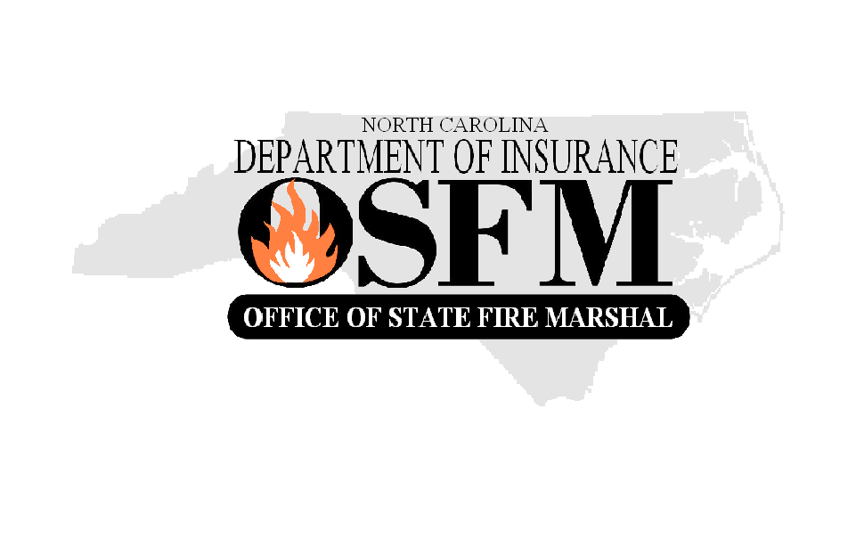
FOR OFFICIAL USE ONLY

Attach Photo Here

North Carolina
Department of Insurance
Office of State Fire Marshal
1202 Mail Service Center
Raleigh, NC 27603-3400

Permit Type: 􀂅 Pyro 􀂅 Prox
Permit No.: __________________
Permit Expiration Date ____________________________

Application for Pyrotechnic Operator Assistant
or Proximate Audience Operator Assistant License

Any person that conducts pyrotechnic or flame effect displays in N.C. must be permitted by the OSFM pursuant to N.C. General Statute (14-410) Please provide the following information
(TYPE OR PRINT IN BLACK INK):

Type of Permit:

New Applicant: 􀂅 Pyrotechnic Assistant 􀂅 Proximate Assistant

- Name / Address of Applicant
FOR OFFICIAL USE ONLY

PGI Qualification
Certificate Attached 􀂅 Yes 􀂅 No

APA Qualification
Certificate Attached 􀂅 Yes 􀂅 No

Other OSFM Approved Class
___________________ _____________
INSTRUCTOR DATE

Name: ______________________________________
Address: ____________________________________
City: _________________________ State: _________
Zip Code: _________ County: ___________________
Phone: ( ) ______________________________
Fax: ________________________________________
E-Mail Address: _____________________________

The information contained in item #2 will appear in the OSFM Pyrotechnic Directory

- Name / Address of Pyrotechnic Delivery Agency 􀂅 DO NOT PUBLISH

Name: ______________________________________________________________________
Address: ____________________________________________________________________
City: ________________________________ State: __________________________
Zip Code: _________________ County: ___________________________________
Phone: ( ) _________________________________ Fax: __________________________________
E-Mail Address: ________________________________________________

Application for Pyrotechnic Operator Assistant
or Proximate Audience Operator Assistant License

Each of the following questions must be answered by checking the “Yes” or
“No” box. Give full details on a separate sheet for each “Yes” answer.
Yes No
3. Has a court ever declared you incompetent by reasons of mental or physical
defect or disease? 􀂅 􀂅

4. Have you ever been committed to a mental institution? 􀂅 􀂅

5. Are you an unlawful user of, or addicted to marijuana or any depressant,
stimulant, or narcotic drug, or any other controlled substance? 􀂅 􀂅

6. Are you a fugitive from justice? 􀂅 􀂅

7. Are you an undocumented immigrant to the United States? 􀂅 􀂅

8. Are you under indictment in any court for, or have you ever been convicted
of a felony or any crime for which the judge could imprison you for more than
one year? 􀂅 􀂅

9. Have you ever been discharged from the armed forces under dishonorable
conditions? 􀂅 􀂅

10. Having been a citizen of the United States, have you ever renounced your
citizenship? 􀂅 􀂅

11. Have you ever willfully violated any provisions of the Pyrotechnic
Operator Permitting Law (NCGS14-410)? 􀂅 􀂅

12. Have you made a material misstatement or knowingly withheld information
in connection with any original or renewal license application? 􀂅 􀂅

13. All Applicants Must Submit the Following:
􀂅 A copy of your driver's license or other government issued identification that includes
the date of birth and photograph. Submit as Attachment A.

􀂅 A photograph (2 inch x 2 inch) taken within the preceding six months. The photograph must
be clear, front view, full face, head and shoulders only, without glasses, hats,
scarves or any object that obscures the identity of the applicant. Submit as Attachment
B.

􀂅 Assistant Affidavit attesting to your experience if any and the employment by the ATF license holder under which you received clearance (Not required if applicant is ATF Licensed or licensed in another state). Proximate Operator Assistants are not required to have ATF clearance but are required to be insured.

􀂅 A list of pyrotechnic licenses issued to the applicant by other states. Submit as
Attachment D. A photocopy of all listed licenses shall be included with this application; consideration will not be given to listed licenses without an accompanying photocopy.

PYROTECHNIC PERMIT APPLICANTS PROCEED TO #14
PROXIMATE AUDIENCE MAY SKIP TO #15.

2

Application for Pyrotechnic Operator Assistant
or Proximate Audience Operator Assistant License

14. Assistant Operator Permit Applicants Must Also Submit the Following:

􀂅 A Copy of BATFE License, Permit, proof of a license in the renewal phase (Required for all Permitted Pyrotechnic Operators Assistants, Attachment E)

or

􀂅 Copy of BATFE Letter of Clearance and a notarized affidavit from a license holder under which the applicant is employed or contracted (Attachment F)

15. Permit Fee: Please include a check or money order made payable to the “The North Carolina Department if Insurance” for the license fee of:

Pyrotechnic Operator Assistant License $30

Proximate Audience Operator Assistant License $30

BY MY SIGNATURE I AGREE TO REPORT TO OSFM ANY CHANGE TO MY STATUS WITH REGARD TO ANY OF THE QUESTIONS NUMBERED 3-12, INCLUDING CONVICTION FOR ANY FELONY, OR CONVICTION FOR ANY ALCOHOL OR DRUG RELATED OFFENSE, REGARDLESS OF MISDEMENOR OR FELONY, WITHIN 24 HOURS OF OCCURANCE.

I certify that all information contained herein, and all information and documents attached
hereto, are accurate, true, and complete. My signature authorizes the OSFM to verify the answers I have given in response to Questions 3, 4, and 5 with identified medical facilities and medical care providers
related to the treatment of a mental or physical defect, disease or addiction.

Signature: _

Print Name: _

License No.: _ Date: _

Signature and Information in this Section in Blue Ink Only

Failure to sign forms, submit necessary information, provide attachments, or enclose
check or money order will cause your application to be denied and no license will be
issued until all requirements are complete.

Application for Pyrotechnic Operator Assistant
or Proximate Audience Operator Assistant License
Attachment D – List of Licenses Issued by Other States
ATTACH COPIES OF ALL LICENCES
NAME ON LICENSE | STATE | ISSUING AGENCY | TYPE OF LICENSE | LICENSE NO. AND EFFECTIVE DATES
License No.:
Issued:
Expires:
License No.:
Issued:
Expires:
License No.:
Issued:
Expires:
License No.:
Issued:
Expires:
License No.:
Issued:
Expires:
License No.:
Issued:
Expires:
License No.:
Issued:
Expires:
License No.:
Issued:
Expires:
License No.:
Issued:
Expires:

License No.:
Issued:
Expires:

