Off-Campus 2-day Courses Online Application Process – Virtual Classes:
The USFA online admissions application can be found:
https://training.fema.gov/generaladmissionsapplication/staticforms/startapplication.aspx

If a student has an issue or a question regarding the online admissions system or the process, please contact:
NETC Admissions Department
(301) 447-1035
NETCAdmissions@fema.dhs.gov

April Classes appear now – so you can select them. The classes in May through July will be ready for registrations within the next two (2) weeks.

Tutorial:
The student must input their FEMA Student ID and first/last name. If you do not already have a FEMA Student ID (SID), go to https://cdp.dhs.gov/FEMA SID to register for one. The FEMA SID is ten digits
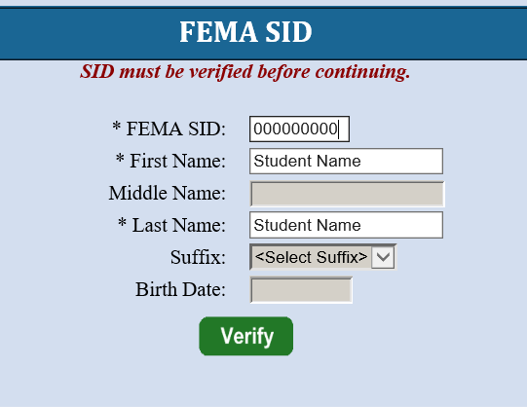
Click Verify
The system will return the middle name, suffix, and date of birth from the SID system.
You will see “Verified!” if all information is good.
Click NEXT

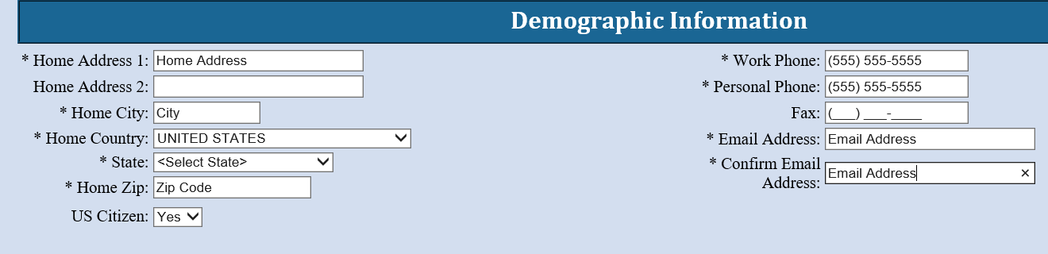

Complete the fields on the Demographic Information screen. Starred fields are required.
Click NEXT

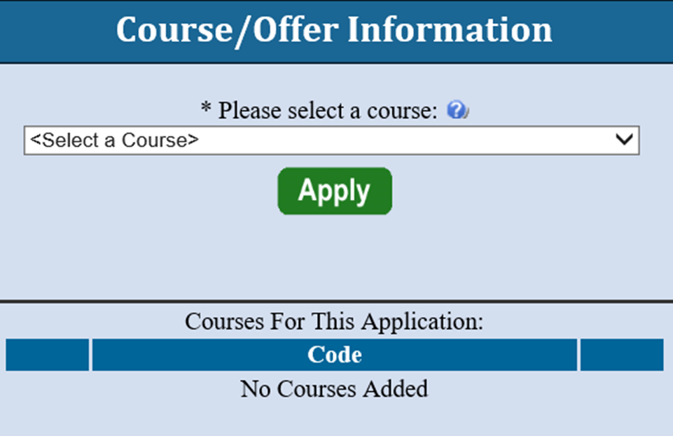

The Course/Offer Information screen requires the student to select a class.
The student must select the drop-down arrow and scroll to the “S Course Codes” for 2-day off-campus classes.
Click APPLY
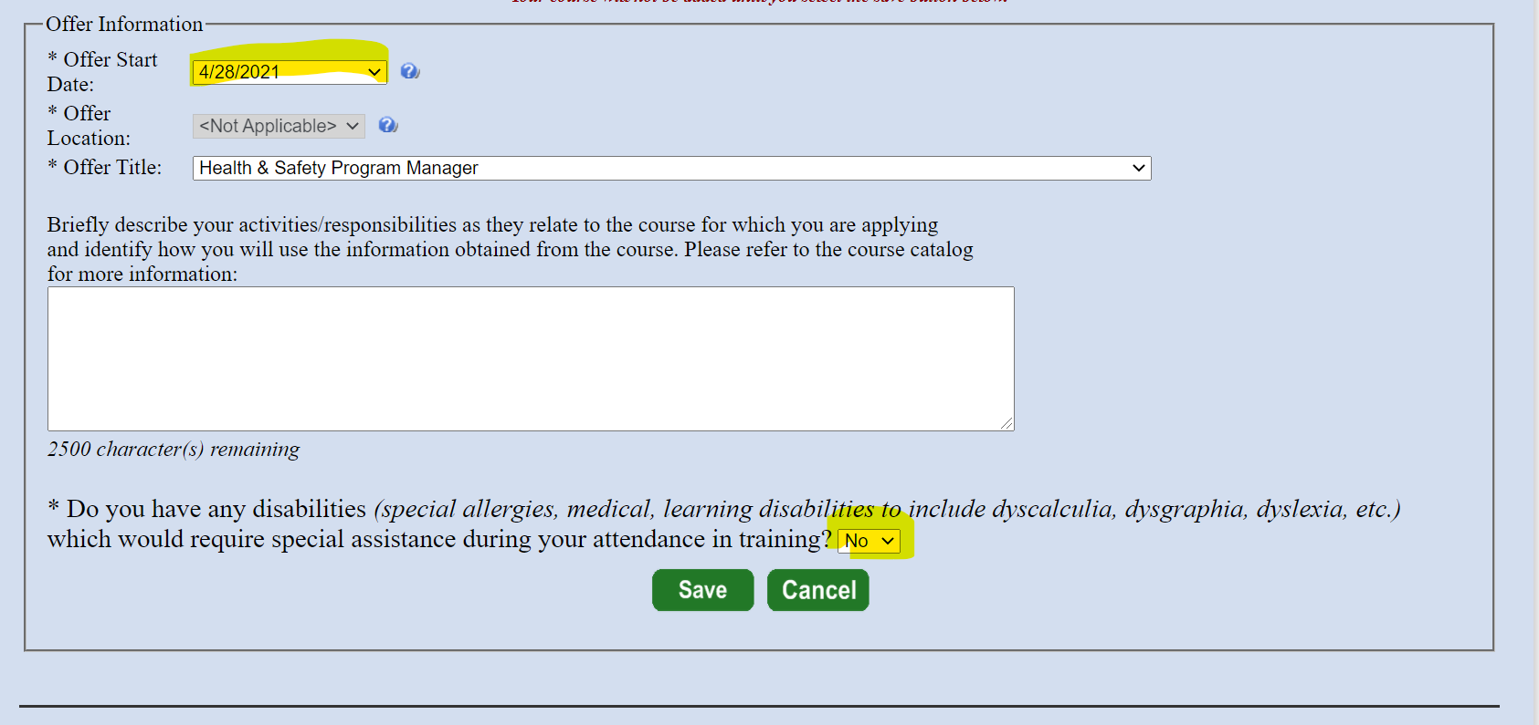

- Select date – it will automatically fill in the Offer Title.
- For a 2-day off-campus class the student does not have to input their activities/responsibilities related to their course.
- Answer NO for disabilities
- Click SAVE

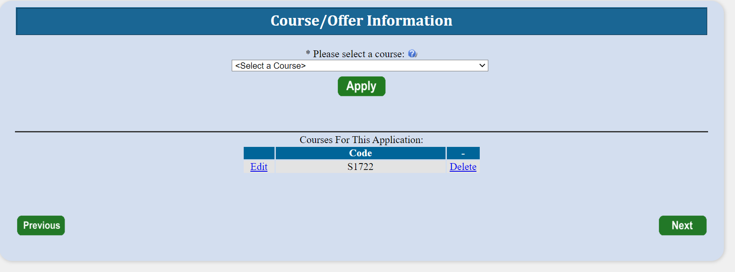

Click NEXT

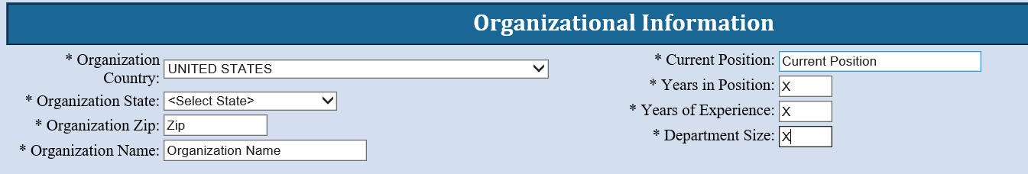

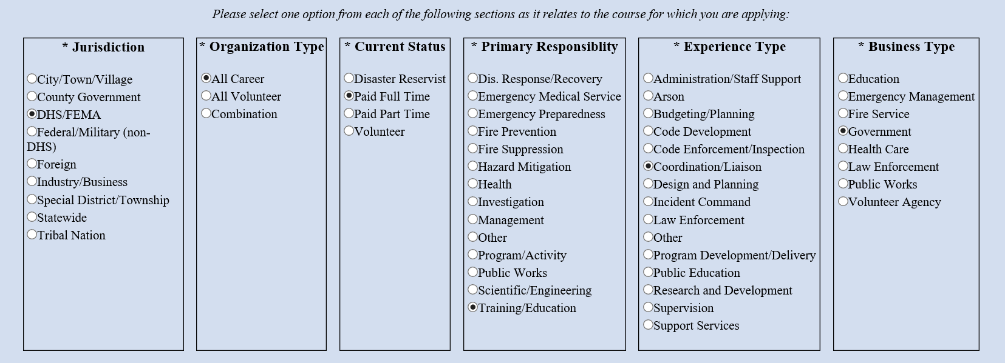

Once on the Organizational Information section the student must fill in all information requested.
Click NEXT

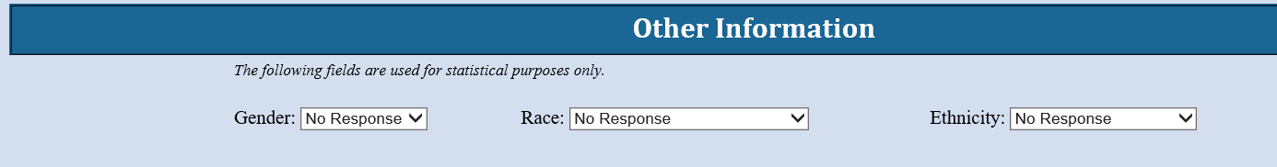

This section is optional. These fields are used for statistical purposes only.
Click NEXT

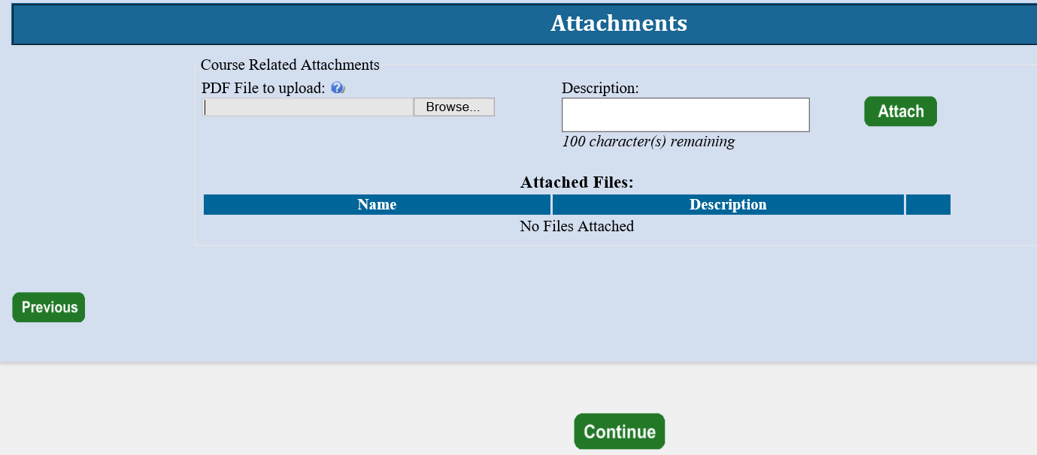
For a 2-day off-campus class the student does not have to input an attachment related to their course.
Click NEXT

The Head of Organizational Information is when the student inputs the State Coordinator’s/POC’s information. The State Coordinator’s/POC’s information must be input to be placed into class.

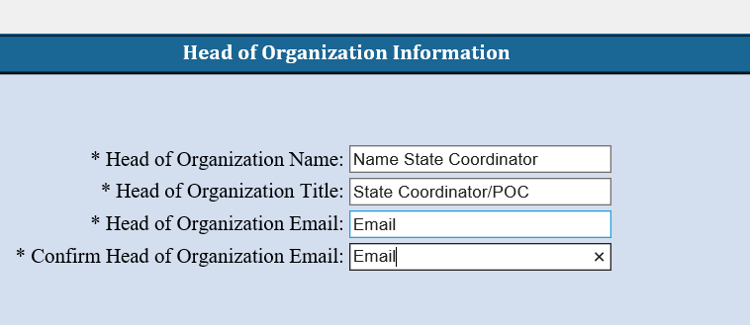
Please copy and paste the following into the
Head of Organization – Monna Gillespie
Head of Organization Title – Administrative Specialist I
Head of Organization Email – monna.gillespie@ncdoi.gov
Confirm Head of Organization Email – monna.gillespie@ncdoi.gov
Click Continue

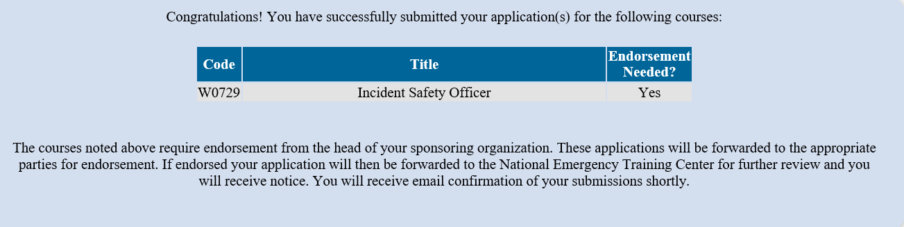

Congratulations – you have completed the registration process.

